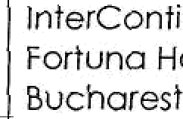
Outsourcing

Bucharest
"-" "' ” TODAY ”

EVENTS AGENDA 2019
bringing toge\hei Romanian and foreign businesses, ministers, Government officiols and international specialists, our events foster o culture of sharing the best practices from Romonio and ob‹oad, while establishing
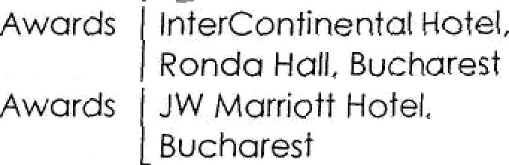
on exclusive platform for networking ot the highest level.

Morch 28 | Eneroy CEO Fotum & Energy Awords, 8 * Edition |  | Energy | Forum &  Gola
May 7 | Romanian Business Services Forum & Awords, Sch Edition |  | Outsourcing | forum &
AAoy14 | Dioitol Transformation Conference, 3‹d Edition |  | Cross-sector | Conference | InterContinentol Hotel.  Forfuno Hall Bucharest
June 4 | L eornino & Development Conference, 3rd )@ |  | Humon  Resources | Conference | Hotel,
September 26 | Smorf Troosformation Forom. 4 h Edition |  | SmotCDy | Forum | InterContinen›al Hotel,  Ronda Hall Bucharest
October 3 | Automotive Industry Forum & Automotive Indu4 | Awords | Automotive | Forum &  Gala | Rodisson 8Iu Hotel,  Buchorest
October 30 | People in Business Services Forum,  5* Edition |  | Outsourcing | Forum | Rodisson8luHotet  BuchoresT
November | Workplace of the future, 3 Edition |  | Human  Resources, Reol  Estote | Conference | Bucharest
Decembe› | The Diplomof-Bucharest Awords Polo, JS yeors Anniversary  S@eciol Edition |  | Business  Excellence | AvvQrds Galo | Bucharest

